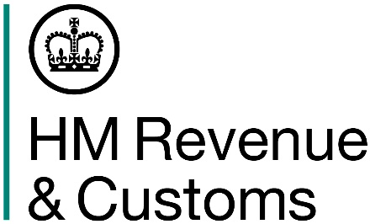

Customs Declaration Service: Waiver document code ‘999L’ extension

Dear Customer,

We are writing to you to let you know that the use of waiver document code ‘999L’ on declarations submitted through the Customs Declaration Service (CDS) has been extended for use on ex-heading goods. This is where declarants have confirmed there are no documentary or licensing requirements applicable for the goods being imported or exported.
You can continue using waiver document code ‘999L' on your CDS declarations until:
- 31 January 2024 for imports

- 31 January 2025 for exports

After these dates, the waiver document code ‘999L’ will be permanently removed.
Declarants should be aware that 999L is not a Union Customs Code (UCC) permitted code and cannot be used for imports or exports relating to Northern Ireland (NI).

Why is use of waiver document code ‘999L’ being extended?

HMRC listened to feedback from declarants and external partners and introduced temporary waiver document code ‘999L’ to make the move from the Customs Handling of Import and Export Freight (CHIEF) system to CDS as smooth as possible.

We have extended the use of the code to help declarants who have only recently moved their import declarations from CHIEF to CDS. The extension of the code will also support declarants as they begin to move from CHIEF to CDS for exports.

What happens when waiver document code ‘999L’ is removed?
Over the coming months, HMRC will be introducing national waiver document codes that will initially be available alongside ‘999L’. These codes will eventually replace the temporary waiver document code ‘999L’.

National waivers were uploaded to import measures in the UK Tariff on 1 July 2023 e.g., HMI Conformity Certificate measure (doc code 920Y) and Animal Health Certificate measure (Animal Pathogen) (doc code 912Y). These will shortly be followed by waivers for use in Chapter 44 for the Quarantine Release Certificate (QRC) measure.

We would encourage declarants to start using these national waiver document codes or EU waiver document codes when submitting import and export declarations through CDS. This will help to ensure you’re familiar with how these codes should be used before 999L is permanently removed.

Declarants are reminded they are legally obliged to check and confirm that the consignment is entitled to the waiver they are claiming.

Help and support
We have provided a number of resources and guidance online to help you submit your declarations through CDS. For more information, you can:

- read the latest Customs Declaration Service guidance on GOV.UK - including the customs declaration completion requirements for Great Britain – to familiarise yourself with the Customs Declaration Service.

- access example import declarations on GOV.UK which provide guidance on how to complete data elements for a range of GB import declarations.

- watch our videos and recorded webinars on topics like imports, exports, rules of origin, and import or export declarations on the HMRC YouTube channel.

Here to help
If you have any questions, please contact us through your usual channels of communication or through your Account Manager or Customer Compliance Manager, if you have one.

Kind regards,

HMRC

